|  |  |
| --- | --- |
| **SYLLABUS**  pensmall.jpg  English 100 Accel College Prep WritingFall 2019 A A Stevens | **L**os **A**ngeles **T**rade **T**echnical **C**ollege  **F:** 29326: Lecture 8-10:05 AM, Room B2-233  **F:** 29937: Lab 10:10-12:5 AM, F TBA  Office Hours: 7:30 AM, Room B2-233    **stevens2.jpg**  **E-mail:** See “Attendance” below. |

|  |  |  |  |  |  |  |  |  |  |  |  |  |  |  |  |  |  |  |  |  |  |  |  |  |  |  |  |  |  |  |  |  |  |  |  |  |  |  |  |  |  |  |
| --- | --- | --- | --- | --- | --- | --- | --- | --- | --- | --- | --- | --- | --- | --- | --- | --- | --- | --- | --- | --- | --- | --- | --- | --- | --- | --- | --- | --- | --- | --- | --- | --- | --- | --- | --- | --- | --- | --- | --- | --- | --- | --- |
| |  |  |  |  |  |  |  |  |  |  |  |  |  |  |  |  |  |  |  |  |  |  |  |  |  |  |  |  |  |  |  |  |  |  |  |  |  |  |  |  |  |  | | --- | --- | --- | --- | --- | --- | --- | --- | --- | --- | --- | --- | --- | --- | --- | --- | --- | --- | --- | --- | --- | --- | --- | --- | --- | --- | --- | --- | --- | --- | --- | --- | --- | --- | --- | --- | --- | --- | --- | --- | --- | --- | | ***Classroom Electronics:***NO texting/cells/iPods/ear buds.Whenever necessary, please take all electronics outside our room to use **before, during and after class**.   Laptops, tablets and smartphones are allowed in the 1st & 2nd rows only, so please get here early if you need to use your laptop, smart phone or tablet for class activities. Use of electronics is a privilege. Also, in 1st & 2nd rows I check screens to ensure users are doing English 100 activities.  **Department, Course and Units:** English Depart., Eng. 100, Intermediate Reading & Composition, 3 Units, 3 hour Lecture  **Academic Requirements**: In this course, students plan, draft, revise, and edit compositions of increasing complexity, progressing from multiparagraph essays to a research paper (1000-1500 words). Writing is based on readings that cover topics of intellectual background for the assignments. Readings may focus on fiction, nonfiction, and/or memoirs. This course prepares students for English 101 (UC/Cal State transfer English).  **Course Objectives**: Write a variety of sentence forms and paragraphs in essays using coordination, subordination, and transitional words & phrases.  Lastly, produce a four page Research Paper (RP) from critical reading assignments and essays Parts 1-4 pasted into Research Paper with a thesis, citations, and Works Cited page.   |  |  |  |  | | --- | --- | --- | --- | | Research Paper Part I Research Paper Part II Research Paper Part III Research paper Part IV  RP 500-100 Words  Final Exam—topic TBA | 10%  10%  10%  10%  20%  40% | bracket | * Self-Corrected Research Paper (RP) Parts 1-4 pasted into a single MLA formatted MS Word document. Use LATTC’s lab if you do not have a computer**. See page 3 for RP details.**  **RP approximately 1000-1500 words, 2-3 pages** (See pg. 3) |   **REQUIRED Textbook—**Purchase and bring to 2nd class:  ***Rules for Writers****,* Diane Hacker, current edition, Bedford/St. Martin’s. **REQUIRED REQUIRED REQUIRED**  **USB Flash Drive** required for course credit and additional assistance.   |  |  |  |  |  |  |  |  |  |  |  |  |  |  |  |  |  |  |  |  |  |  |  |  |  |  |  |  |  |  |  |  |  |  |  |  |  | | --- | --- | --- | --- | --- | --- | --- | --- | --- | --- | --- | --- | --- | --- | --- | --- | --- | --- | --- | --- | --- | --- | --- | --- | --- | --- | --- | --- | --- | --- | --- | --- | --- | --- | --- | --- | --- | | **Make-up Policy**   1. *\* **What you need TO DO when you are sick or miss class*. NO LATE WORK ACCEPTED:*** The week you are absent get the assignment from a classmate and e-mailit to[**stevenaa@lattc.edu**](mailto:stevenaa@lattc.edu)**. Subject box**: “Absent Work”—no excuse needed or *required*. Keep text box empty. (When you return the next week, DON’T ask me what the assignment was because you were sick; you already e-mailed it to me, and I graded it. Pick it up. Student phone numbers in #2 below are very   Important to get assignments and do homework even if you are absent.) ***Hint: NO* email accept after 8TH week.**   1. Get and program 3 cell phone numbers from your class members NOW. So, you can get and complete the homework when it is due, the week you're absent. ***If you have unhelp phone numbers, get new ones the next time class meets.***   **Attendance**  Attendance taken from work turned-in during class only. Absences CANNOT be excused even if sick, doctor, court, death, etc. so you are dropped after three absences. (FYI: You are not required explain why you missed class—ever.)  2 absences + 2 lates/leave early = 3 absences; as a result; you are dropped from this class—**State Law. You are an adult; no excuses expected or required.**    **Web Site:** Students are required to check it weekly: [www.english28stevens.com](http://www.english28stevens.com) .  **Grading Scale:** Essay assignments, problem solving exercises, skills demonstrated, tests, homework, class discussion, projects—letter grades given the following points: A 100-90, B 89-80, C 79-70, D 69-60, F 59 and below (Minuses not given on LATTC grade records.)  **Calendar of Activities. 8/26/19 to 12/15/19**   |  |  | | --- | --- | |  | ACTIVITIES | | **30 AUG** | Syllabus, Purchase textbook—see Syllabus page 1 and create textbook labels. LAB: Lab introduced. | | **6** | Writing activity, grammar and punctuation review—complex, subordinator (19a). LAB: Complex. | | **13** | Writing Activity, punctuation review, **compound, coordinators (32a**)**. LAB**: Very last punctuation lab practice of sentence types and sentence variety—simple, complex, compound. | | **20** | Writing Activity, **Punctuation Exam**, topic sentence (3a), coherence. LAB: Create topic sentences for model http://writeabetternovel.net/wp-content/uploads/2011/01/pilcrow.jpgs. | | **27** | RP Part 1: Make a planner: chart or outline, create topic sentence. LAB: Create http://writeabetternovel.net/wp-content/uploads/2011/01/pilcrow.jpgs with topic sentences created from your planner. | | **4 OCT** | Writing Activity, topic sentences, coherence using synonyms: LAB: More planner & TSs for RP Part 1.  RP Part 1 (RP = Research Paper). | | **11** | Writing Activity, transitions (34b), coherence using subordinators and transitional words for http://writeabetternovel.net/wp-content/uploads/2011/01/pilcrow.jpg development, citation introduction and citation integration explained. LAB: Select citations and integrate them into your RP. Research Like a Pro! Format your citation introductions.  RP Part 2 | | **18** | Coherence (synonyms and subordinators, research paper http://writeabetternovel.net/wp-content/uploads/2011/01/pilcrow.jpg development, citation introduction and citation integration. LAB: Research like a pro. Select Citations and integrate them into your RP.  RP Part 3 DO NOT E’MAIL AFTER 8TH WEEK | | **25** | Research Paper’s thesis statement CREATED**: LAB**: Write a thesis for your RP–collected.  DON’T E-MAIL WORK  **RP Part 4** | | **1 NOV** | Citation Introduced and Integrated using textbook and [www.english100stevens.com](http://www.english100stevens.com). LAB: Create two **book** citations introduced and integrated into your RP—collected. DON’T E-MAIL WORK | | **8** | Citation Introduction and Integration using text and [www.english100stevens.com](http://www.english100stevens.com). LAB: Create two **web** citations introduced and integrated into your RP—collected. DON’T E-MAIL WORK | | **15** | Citation Introduction and Citation Integration, Works Cited page explained. LAB: Create two additional **web** citations introduced and integrated into your RP—collected. DON’T E-MAIL WORK | | **22** | Research Paper: Collected  Create RP: *Combine* Parts 1, 2, 3, 4 into one doc and MLA format it. DO NOT E-MAIL | | **29** | Thanksgiving Holiday | | **6 DEC** | RESEARCH PAPER DUE, a DEADLINE—cannot be sent by e-mail. Can be turned in early. No late work accepted. If not attending, please have it delivered promptly at beginning of class, or your grade will be determined using digital copy placed on instructor’s computer three weeks ago. Final Exam explained. DON’T E-MAIL. | | **6** | Final Exam, required (no exceptions). Make arrangements to be present. Writing paper provided by Instructor. Bring one stamped 8 x11 envelope. | | **13** | Final Evaluated |   -----------Disclaimer: Syllabus/Calendar subject to change. Any changes will be announced by instructor--------  **Research Paper (RP) English 100**   1. **RP 1-4**—1000 to 1500 words—(noted in diagram below) are written separately over a period of four to five weeks. TITLE and SAVE each essay in this way: **Part 1, Part 2, Part 3 and Part 4** to your flash drive. 2. **As a result**, within several weeks you will have RP Parts 1-4 completed and pasted into **one** MS Word document and saved on your flash drive labeled with your last name only. If your name is Jessica Delgado, SAVE your research paper **Delgado RP** on your portable drive (flash drive—NOT on a Clouds server or   E-mail or saved on cell phone).   1. as   **Research Paper, Fast Food Nation**  ***Explain* why you eat FF. Provide details about its good taste and low-cost.**  **Part 1: Use your planner for each part to create a topic sentence.**  **Why you need FF due to your busy lifestyle**  Then create a topic sentence, using this temple: **There are several reasons my busy schedule makes it necessary for me to eat fast food, such my work, school, and chores**. Lastly, use you planner to add words and create sentences using your sub circle words:  Chores | | |

Attend classes

Homework

For example

**Basic**—**Correction Symbols Defined*:*** *BASIC Writing Skills (High School & Middle School*)

**NEVER USE THESE WORDS in your paper—ever**

|  |  |  |  |  |
| --- | --- | --- | --- | --- |
| **You**, your never never never | **always** | **also**—use beginning of sentence only | person | these |
| **would, should, could** | **Start** **started** | **because**—Don't use 1st sentence 1st par. | still | begin |
| **so that**—use “so” | sometimes | everyone | only | just |

|  |  |  |
| --- | --- | --- |
| **SYM** | **SEC** | **Correction Needed** |
| http://writeabetternovel.net/wp-content/uploads/2011/01/pilcrow.jpg |  | Begin new paragraph. |
| **🡩** |  | **Add missing word** or words, so sentence or phrase makes sense |
| **^** |  | **Insert comma** (1) Sentence begins with an introductory word or phrase, insert comma (34b)  **OR** (2) Subordinate clause begins sentence, instert comma (19a). |
|  |  | **Underlined**: Word, phrase, sentence does not make sense. Most likely slang or translation. Delete/ omit. |
| **O**ed |  | Omit **Circled** Word **or** Words: Indicates word(s) not necessary. |
| **Agr** | **21a-c** | Error in **Agr**eement, both subject and verb need to be plural or singular. Wrong: He run. Correct: He runs. |
| **CS** | **32a** | **C**omma **S**plice**. Comma can’t connect two sentences. Need comma + coordinator (32a).** |
| **STL** | **🡪** | **S**entence **T**oo **L**ong**: write simple** (Sec 49)**, *complex*** (19a)**, compound** (32a) **sentences of only 10-12 words** |
| **Frag** | **47a, b**  **19a** | **Frag**ment, not a sentence**. (1) Missing a verb** (47a) **or subject** (47b) **OR**  **(2) Sentence begins with a *subordinator* without 2nd sentence** (19a). |
| **RO** | **20a-d** | **R**un-**O**n**, two sentences run together w/o punctuation. (1) Needs a comma + coordinator** (32a)  **(2) Use a *subordinator*** (19a) **(3) Use semicolon** (34b) |
| **Para S** | **🡪** | **Para**llel **S**tructure. Expressing similar ideas in similar form: Betty wrote, and she was teaching at times—wrong. Betty wrote and she taught at times—correct. |
| **Trans** | **34b** | **Trans**itions**—Need to add transitions for coherence** (Coh).Example: Students let circumstances determine their future; consequently, they need to create a simple plan to succeed. |
| **Coh** | **3d** | **Coh**erence**—**Writing does not proceed in a sensible order. **Hint**: repeat ***key words*** and use ***transitions***. See **TS** above& **Trans** below. |
| **TS** | **3a** | No **T**opic **S**entence**—needs a topic sentence.** Example: There are several reasons why I enjoy eating fast food**,** such as its low prices, good taste, and convince. |
| **Series** | **9a** | Series not parallel. Need to match words, phrases, and clauses (9a):  **Wrong:** I left my name, number, and I left a message. **Correct**: I left my name and number, and I left a message. |
| **Pl..Sing** | **🡪** | Change to **Sing** = change to singular  **or Pl** = change to plural. |
| **PnRef** | **🡪** | **P**ro**N**oun **Ref**erence**,** Identify pronoun before using it (23a)t. Identify “**she**” as my **sister** before using “she.” **OR**  Used wrong pronoun **for the previous noun or next noun** |
| **SP** | **🡪** | **Sp**elling, word misspelled. Correct spelling—use spell check more accurately. |
| **Verb** | **8** | Used a “Be” verb. Create an active verb (Sec. 8): **Wrong**: **I** *am always* **run***ning*. **Correct**: I run. or I ran. |
| **VT** | **13b** | **V**erb **T**ense: Verb tense not consistent within sentence or from previous or past sentence (13b).  For example: **Wrong**—I was **lost**, and a stranger **helps** me. **Correct**: I was lost, and a stranger **helped** me. |
|  |  |  |

**Labels for Textbook**

|  |  |  |
| --- | --- | --- |
| **Book Label** | **Book Sec.** |  |
| **BE/V** | **46c** | BE Verb |
| **Prep** | **46f** | Prepositions |
| **CX Sub** | **19a** | Subordinators, CX = Complex |
| **C Coor** | **32a** | C = Coordinator |
| **Trans ;** | **34b** | Transitions, semicolon |
|  | | |
| **Book** | **Page 446** | Works Cited Format |
| **Web** | **Pahe 452** | Works Cited Format |

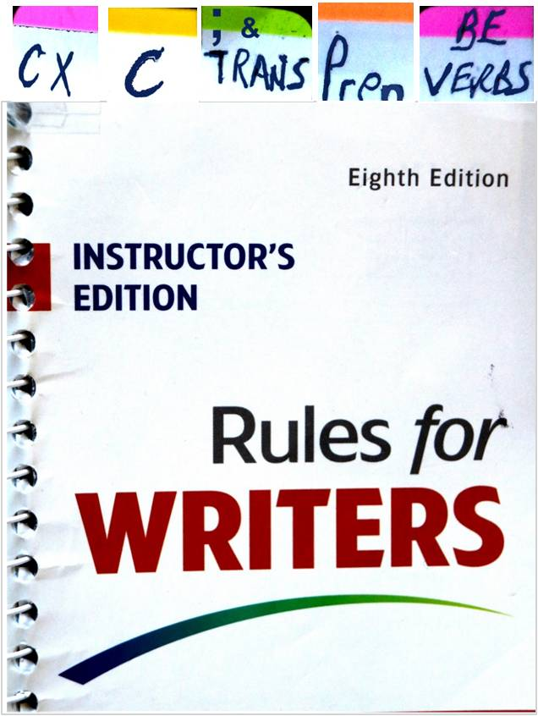

**English 100 Definitions**

|  |  |  |  |
| --- | --- | --- | --- |
| **Book Section** | | | **Summary** |
|  | |  |  |
|  | 1c | | **Thesis** Statement needed—Statement explains the main point of paper: Summarizes the content of the **Topic S**entences from each paragraph at end of the **O**pening **R**emarks (below). |
|  |  | |  |
|  | 1e | | **O**pening **R**emarks: A simple statement that addresses the topic indirectly without facts, examples, details, or specifics of 50-300 words: Fast food really tastes incredible; I am addicted to the smell and taste of fast food, especially the French fries.  I enter McDonald’s and my mouth begins watering from the magnificent smell of the fries. This short statement of 50-100 words usually comes just before the thesis in the same paragraph. |
| ***Citations:*** | | |  |
|  | Goto: [www.english28stevens.com](http://www.english28stevens.com) | | **C**itation **Intro**duction(Signal Phrase)**: I**ntroductory phrase needs: author and source. See Citation Introduction in the shaded area below:  When meatpacking cleaning crews clean equipment with high pressure hoses, they are injured due to poor visibility when using safety glasses they can't see clearly. **In his book *Fast Food Nation* Eric Schlosser says,** “Glasses and safety glasses fog up, making it impossible to see other workers” (177). As a result, workers accidently spray each other with a 180 degree cleaning solution. |
|  | **C**itation **I**ntegration**—**Need to connect citation to the sentence before the citation and the sentence after the citation. The sentences above & below the shaded area is the “citation introduction.” |

Grammar: **NOT taught in English 100:** What you should have learned in elementary school.

|  |  |  |
| --- | --- | --- |
| **SKILL** | **BOOK SEC** | **DETAILS** |
| Active Verb | 8 | Active verb (voice) |
| BE Helping-Verb | 46c | Listed—helping verbs—also 8b |
| Simple Sentence | 47 | Simple sentences (subject verb & Patterns 47) |
| Verb tense | 13b | Consistent verb tense |
| Pronoun reference | 23a | Shorthand for nouns |
| SV Agreement | 21a-c | Subject verb agreement |
| Series | 9a | Items in a series & parallel ideas (//) |
| Prepositions | 46f | Prepositions listed & preposition use |
|  |  |  |

**Punctuation**: **REVIEWED in English 100:** There are four sentence structures.

What you should have learned in middle school & high school.

|  |  |  |  |  |  |
| --- | --- | --- | --- | --- | --- |
|  | **SKILL AREAS** | **BOOK SECTION** | **DETAILS** |  | |
|  | Simple (**S** = simple) | 47 | One sentence |  | See samples  of these types  of sentences in textbook, **Sec. 49a** |
| **whistler.gif** | **Subordinator (CX = complex)** | **19a** | **Two sentences plus subordinator** |
| **whistler.gif** | **Coordinator (C = compound)** | **32a** | **Two sentences with coordinator + comma** |
| **whistler.gif** | **Semicolon (C = compound)** | **34b** | **Compound sentence** |
|  | **Complex/Compound** | **195203** | **Three Sentences Sub with Coor. + Comma** |  |  |

**Advanced** Writing: **TAUGHT in English 100**: What you should have learned in high school’s Adv. Composition.

|  |  |  |
| --- | --- | --- |
| **SKILL AREAS** | **BOOK SECTION** | **DETAILS** |
| **Topic Sentence** | 3a | Explains what the **paragraph** is about. |
| **Coherence** | 3d | **Key** Words + Transitional Words: Creates paragraph coherence. |
| **Transitional** **Words** | 34b | Used as transition between 2 sentences OR as introduction to a sentence |
| **Examples** | 3c | Makes your information believable (detailed examples with names, dates, places). |
| **Thesis—**in 1st paragraph | 1c | Not a question, but a statement. Explains what **paper** is about. |
| **Citation** (quote) | On Web | Introduction & Integration at <http://www.english28stevens.com/-citations.htm> |
| **Works Cited** (separate page) | On Web | Works Cited page at <http://www.english28stevens.com/-workscited.htm> |
| **MLA** sample | 57b | Sample of complete MLA formatted paper. |
| **Research Techniques** |  | Research Like a Pro! |

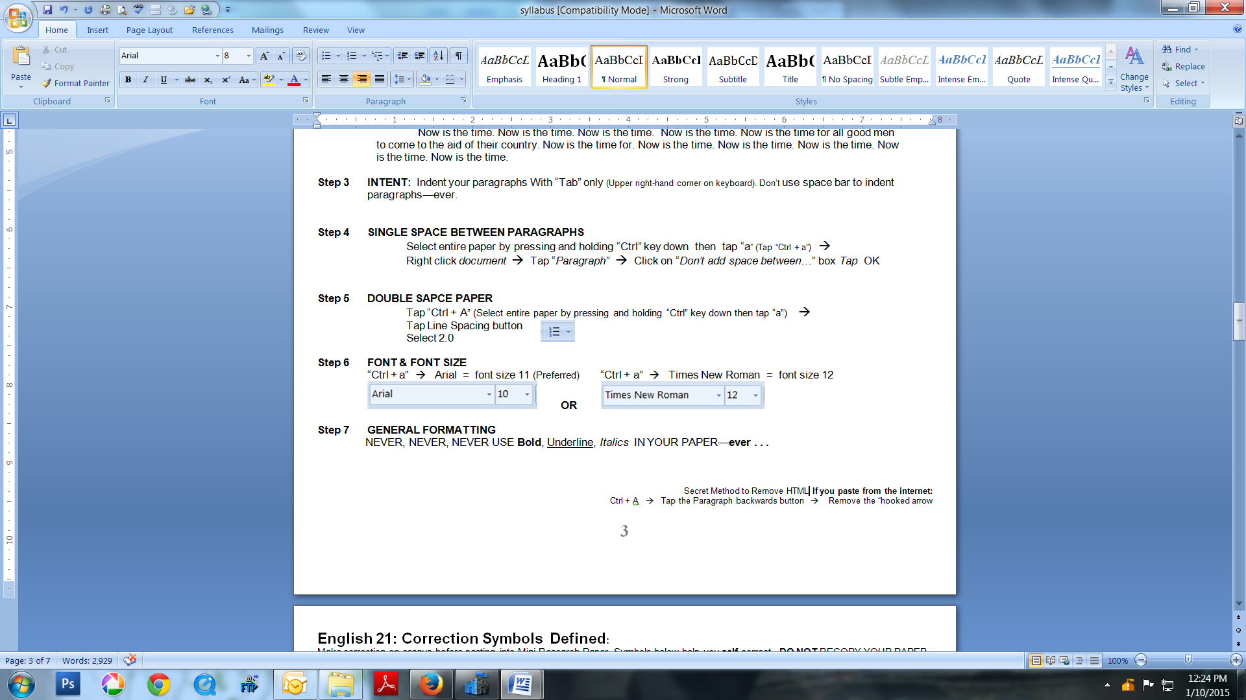Secret Method to Remove HTML **If you paste from the internet:**

Ctrl + A 🡪 Tap the Paragraph (image at right) button 🡪

Remove the “hooked arrows”

**MLA** Formatting Directions

|  |  |
| --- | --- |
| **Step 1** | **HEADING & Body** (Do not do Step 2 until your paper looks like sample below)  Joe Smith  September 30, 2025  English 100  Thursday 2:45 PM  Paper 1 (use center button)  Now is the time. Now is the time. Now is the time. Now is the time. Now is the time for all good men to come to the aid of their country. Now is the time for. Now is the time. Now is the time. Now is the time. Now is the time. Now is the time. Now is the time. Now is the time. Now is the time. Now is the time. Now is the time. Now is the time. Now is the time. Now is the time. |
| **Step 2** | **DOUBLE SAPCE PAPER**  **Hold down “Ctrl” + tap “a”** (Select entire paper: hold “Ctrl” key down then tap “a” on the keyboard)  **Tap** Line Spacing button **Select 2.0** |
| **Step 3** | **INTENT: Indent your paragraphs With “Tab” only** (Upper Left-hand corner on keyboard). Don’t use space bar to indent paragraphs—ever. |
| **Step 4** | **FONT**  “Ctrl + a” 🡪 **Calibri** **=** font **size 11** (Preferred) “Ctrl + a” 🡪 **Times New Roman** = font **size 12**  **OR** |
| **Step 5** | **INSERT HEADER** (right corner)   * On main menu tap: “***Insert***”🡪   + Select “***Page Number***” button 🡪 then Select “***Top of Page***” 🡪 Select 3rd “**box”** down 🡪   + **Type** Last Name ONLY 🡪 🡪 **Tap space bar** **twice** |
| **Step 6** | **REMOVE EXTRA SPACE BETWEEN *PARAGRAPHS***  Select entire paper by pressing and holding “Ctrl” key down then tap “a” on the key board →    Right click *document* → Tap “*Paragraph”* → *Tap*                      →*Tap* OK |

**English 100: GENERAL FORMATTING information:** NEVER, NEVER USE **Bold**, Underline, or *Italics—ever in Eng. 28.*

*Exceptions:* Book title*—Fast Food Nation & Web address—webMD* **Grade Rubric**

Grading Rubric

1. Good: Thesis is clear and supported with examples in body paragraphs.  Examples are cited if applicable.  Conclusion reflects the essence of the thesis. There are very **no grammatical errors**.
2. Fair: Thesis is clear, but examples may need development.  Citations, if applicable, may need further clarification.  Conclusion may stray from topic. There may be a **small number of grammatical errors**, but not enough to hinder comprehension.
3. Poor: Thesis is not clear and lacks support in body paragraphs.  Sources are not clearly cited. Paragraphs contain **many grammatical errors**.

**S**tudent **L**earning **O**utcomes (**SLOs**):

|  |  |
| --- | --- |
| **SLOs** | **Assessment** |
| 1. Demonstrate writing capability | Write a timed in-class Departmental Essay |
| 1. Demonstrate concise, clear paragraph, essay structure | Write well developed, in-class essays with introduction/thesis statement, paragraphed supporting elements with topic sentences and a conclusion, a mechanically-sound 5-paragraph essay. |
| 1. Exhibit critical thinking, analytical skills | Write in-class summaries and analysis of assigned readings. |
| 1. Integrate sources using MLA format | Write (1,000-1,500 words) research paper, demonstrating MLA format. |
| 1. Conduct academic research | Create a MLA formatted research paper featuring the basic components of academic discourse, including a thesis statement, supporting elements, integrated citations, and works cited. |

**Academic Honesty Policy**:

Violations of academic integrity of any type by a student provide grounds for disciplinary action by the instructor or college. Violations of Academic Honesty Policy include, but are not limited to the following actions: cheating on an exam, plagiarism, working together on an assignment, paper or project when the instructor has specifically stated students should not do so, submitting the same term paper to more than one instructor, or allowing another individual to assume one's identity for the purpose of enhancing one's grade. For more information on the Standards of Student Conduct refer to the college catalog and online at [www.lattc.edu](http://www.lattc.edu).

**Disability Support Services (DSS):**

Contact the Disabled Student Programs & Services (DSPS) Center or call 213-763- 3773.

**Course Repeats and withdrawals** now limit the number of times a student can enroll in a credit course to no more than 3 attempts. This includes D, F, W (withdraw), N/C (no credit), N/P (no pass), and INC (incomplete).  Students will not be allowed to register for any course with the LACCD if there are 3 recorded attempts for that same course. 

**Domestic Violence and Sexual Assault:t**

HART (Healthy Advocacy Response Team) and the Physical Education/Health disciplines along with Puente Project are partnering to provide information and direction for survivors of sexual assault and domestic violence.  If you are in need of assistance or have questions about these topics, please to contact: HART:  213 763-7157; Physical Education: 213 763-3732; LATTC Sheriff's office: 213 763-3611 emergency, 213 763-3600; Student Health Center: 213 763-3764. **Additional contact information:** Peace Over Violence 213 955-9090   [www.peaceoverviolence.org](http://www.peaceoverviolence.org); National Organization for Victim Assistance   [www.trynova.org](http://www.trynova.org); Rape and Battering Hotlines   310392-8381   213 626-3393    626 793-3385; National Domestic Violence Hotline: 1 800 799-SAFEl National Sexual Assault Hotline: 1 800 656-HOPE.

**DSPS (Disabled Student Programs Services: Mariposa Hall 100**

This division is responsible for assisting students in their college experience. To achieve these goals the Student Services Division has developed many programs designed to facilitate our student’s assimilation into our college family. These programs are available to you from day one, and will assist you from the moment you submit your application to the day you’re handed your degree.

Rogers 1

Sandra Rogers

Paper Format

June 6, 2025

English 100

Thursday, 2:45 PM

Part 1

The fast food industry’s restaurant owners take advantage of young high school workers for various reasons, such as its bad pay and bad break procedures.

Since it is a younger workers first job, they are not sure of their rights as employees.

For example when I was 16, I had my first job working at Mc Donald’s in Alhambra; I made minimum wage.

I did not take my two fifteen minute breaks because I had no idea I had them.

I was taken advantage of as a teenage worker.

I did not know my rights.

Specifically, it is the law for someone who is working an eight hour shift to have two fifteen minute breaks along with a thirty minute lunch break.

Now that I am an adult, I can take my experience as a teenage worker and learn from it.

When I was a teenage worker, I was taken advantage of.

For example, at my McDonald’s job in Alhambra I did not know how to understand or keep track of my work hours.

However, my mother noticed my checks were short because some of my hours were missing.

As a teenager I had no idea that my check was short.

I love the price of fast food, but I would like to see better laws to protect minors from employee abuse.

As a mother of a teenager, I need to know that my child will not be taken advantage of when he gets his first job.

If my child decides to go into fast food for his first job, I hope that he isn’t taken advantage of, and I like the free food.

The fast food industry is good for its food but needs to treat its workers better more accurate pay and breaks.

Do not leave a blank page in your paper.

Rogers 1

Sandra Rogers

Paper Format

June 6, 2025

English 100

Thursday 2:45 PM

Part 1

The fast food industry’s restaurant owners take advantage of young high school workers for various reasons, such as unfair pay and bad break procedures. Since it is a younger workers first job, they are not sure of their rights as employees. For example when I was 16, I had my first job working at Mc Donald’s in Alhambra; I made minimum wage. I did not take my two fifteen minute breaks because I had no idea I had them. I was taken advantage of as a teenage worker. I did not know my rights. Specifically, it is the law for someone who is working an eight hour shift to have two fifteen minute breaks along with a thirty minute lunch break. Now that I am an adult, I can take my experience as a teenage worker and learn from it. When I was a teenage worker, I was taken advantage of like split shifts and complicated pay stubs. For example, at my McDonald’s job in Alhambra I did not know how to understand or keep track of my work hours since my work hours changed every week. On the other hand, luckily my mother noticed my checks were short because some of my hours were missing. As a teenager I had no idea that my check was short; I didn’t understand the pay stub. I love the price of fast food, but I would like to see better laws to protect minors from employee abuse. As a mother of a teenager, I need to know that my child will not be taken advantage of when he gets his first job. If my child decides to go into fast food for his first job, I hope that he isn’t taken advantage of. The fast food industry is good for its young workers but needs to treat its workers better with more accurate paychecks, better hours, and regularly scheduled breaks.

.